Introduction
The goal of this project is to feed and simulate a 4-element patch antenna array on RO4350B substrate. Our target parameters are:
Operating Bandwidth | 5.725 – 5.875 GHz
Beamsteering Range | ±45°
Gain | 10 dBi

Patch Antenna Design
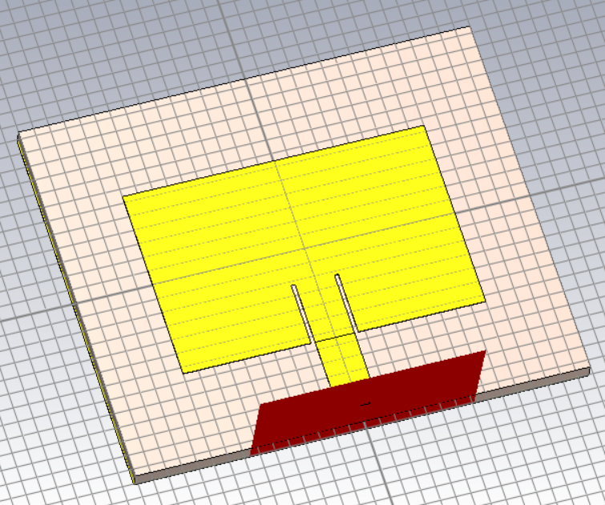
Figure 1: Image of single patch antenna.
Substrate parameters | Values
Ground plane length ($W_{g}$) | 25 mm
Ground plane width ($L_{g}$) | 30 mm
Substrate Thickness ($h$) | 1.2 mm
Relative Dielectric ($ϵ_{r}$) | 3.66
Table 1: Dimensions of antenna substrate.
This paper recommends the substrate thickness to be between $0.003λ_{0}<h<0.05λ_{0}$ [1]. Choosing the middle value in this range (0.0235) gives:
$$λ_{0}=\frac{c}{f}=\frac{299792458 m/s}{5.8 GHz}=51.69 mm$$
$$h=\left(0.0235\right)λ_{0}=1.21 mm$$
Patch dimensions | Values (mm)
Patch length ($L$) | 13.08
Patch width ($W$) | 16.93
Feed width ($W_{f}$) | 2.6
Inset depth ($x_{f}$) | 4.2
Inset gap ($g$) | 0.26
Table 2: Dimensions of patch antenna.
$W_{f}$ was chosen to achieve a 50Ω characteristic impedance given the substrate characteristics. The inset gap width was determined based on this paper, which recommends that $\frac{W_{f}}{g}=10$ [2]. The patch dimensions were first estimated based on $f_{0}$, and then refined using a parameter sweep:
$$W=\frac{1}{2}λ_{0}\sqrt{\frac{2}{ϵ_{r}+1}}=25.84 mm∙\sqrt{\frac{2}{3.66+1}}=16.93 mm$$
Calculating length depends on the effective dielectric of the substrate:
$$ε_{eff}=\frac{ε_{r}+1}{2}+\frac{ε_{r}-1}{2}{(1+\frac{12h}{W})}^{-0.5}$$
$$=\frac{3.66+1}{2}+\frac{3.66-1}{2}{(1+\frac{12(1.2 mm)}{(16.9 mm)})}^{-0.5}=3.31$$
It also depends on the effects of fringing fields [3]:
$$∆L=0.412h \frac{(ε_{eff}+0.3)(\frac{W}{h}+0.264)}{(ε_{eff}-0.258)(\frac{W}{h}+0.8)}$$
$$=(0.412)(1.21 mm)\frac{(3.31+0.3)(\frac{16.93 mm}{1.21 mm}+0.264)}{(3.31-0.258)(\frac{16.93 mm}{1.21 mm}+0.8)}=1.14 mm$$
$$L=\left(\frac{1}{2}λ_{0}∙\frac{1}{\sqrt{ε_{eff}}}\right)-2∆L=14.21 mm-1.13 mm=13.08 mm$$

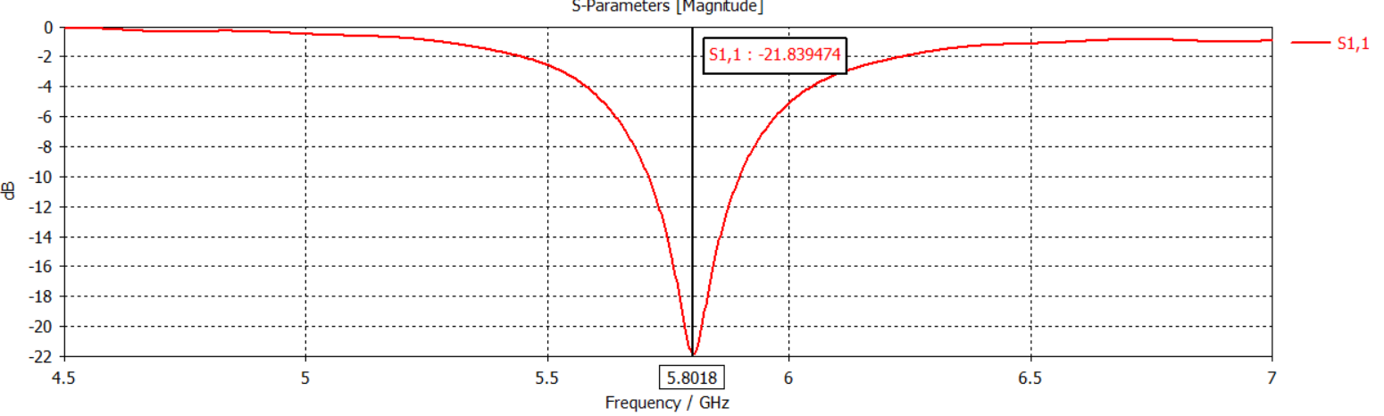
Figure 2: Plot of S11 showing matching at 5.8 GHz.
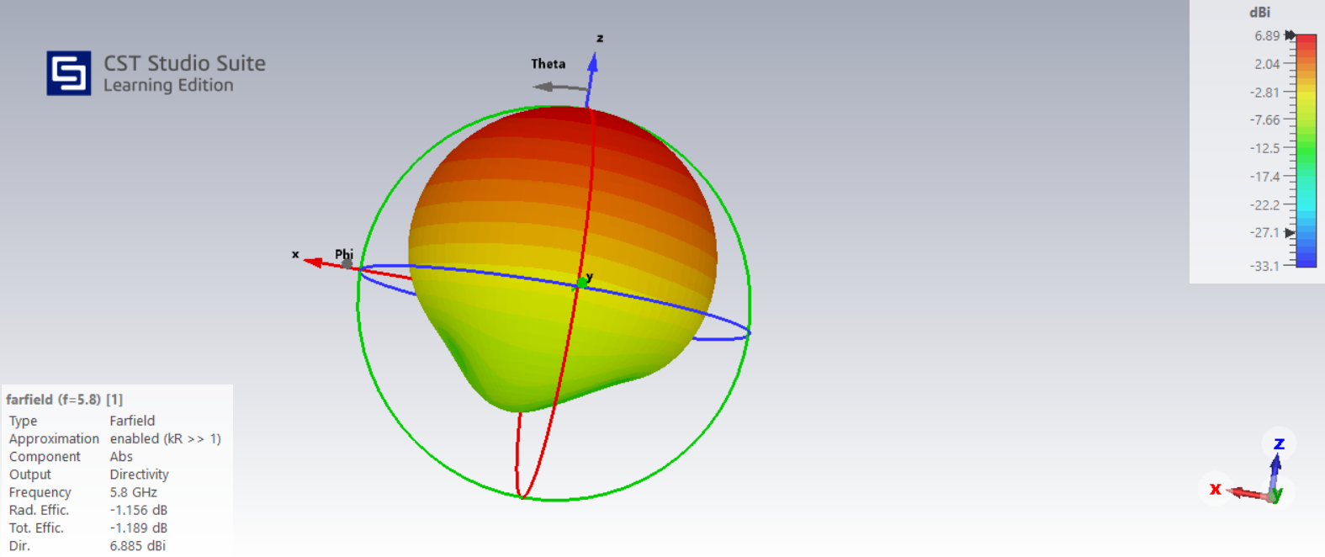
Figure 3: 3D radiation pattern and metrics.
Performance metrics | Values at 5.8 GHz
Return Loss (-S11) | 21.28 dB
Radiation Efficiency ($η$) | -1.156 dB
Gain ($G_{max}$) | 5.729 dBi
Directivity ($D$) | 6.885 dBi
Table 3: Key performance metrics for antenna.

Array Design
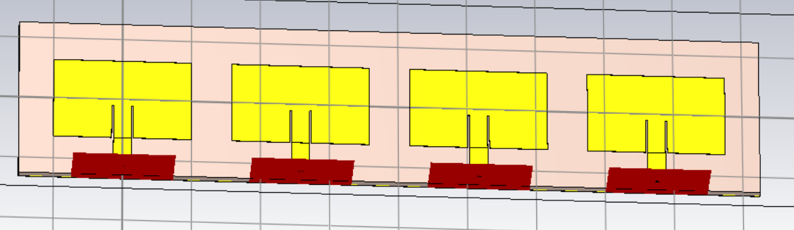
Figure 4: Image of antenna array.
Array Dimensions | Values (mm)
Distance between elements ($d_{x}$) | 25.9
Patch length ($L$) | 12.75
Patch width ($W$) | 20
Ground plane width ($L_{g}$) | 107.52
Table 4: Antenna array parameters.
The patch dimensions were changed from the single-antenna model in the process of tuning the array through parameter sweeping. The distance between antenna elements was set at 0.5$λ_{0}$ to avoid the appearance of grating lobes.
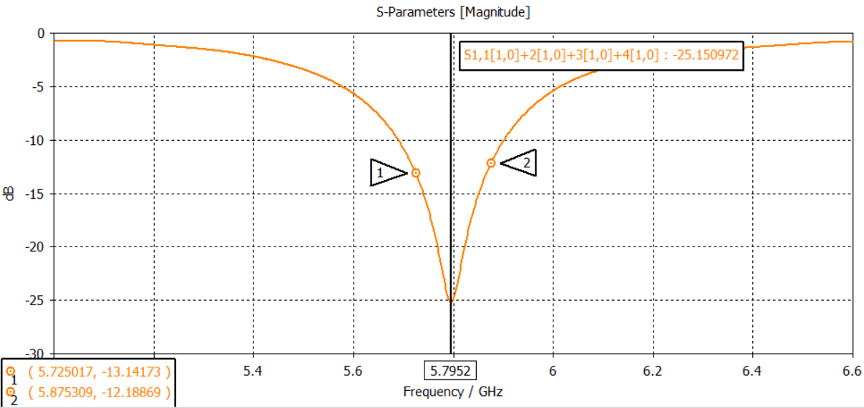
Figure 5: Plot of S11 showing -10dB across the chosen frequency range.
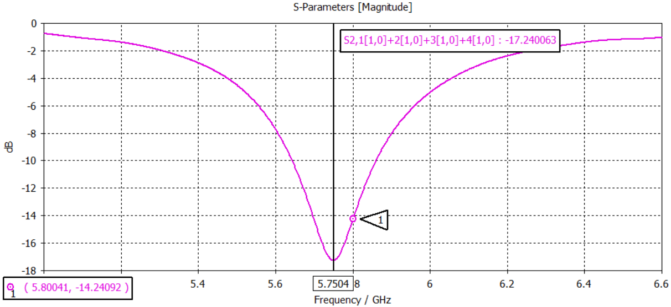
Figure 6: Plot of S21, measures -14 dB at 5.8 GHz and indicative of moderate mutual coupling.

Figure 7: GIF showing beamsteering between ±45°, with prominent side lobes at each end of the range.
The equation governing beamsteering is as follows:
$$∆ϕ=\frac{2πd_{x}sin⁡(θ)}{λ_{0}}$$
When $d_{x}=0.5λ_{0}$, the equation is reduced to:
$$∆ϕ=πsin⁡(θ)$$
Steering the beam to 45° thus requires a phase shift of:
$$∆ϕ=π\sin\left(45°\right)=2.22 rad=127.3°$$
However, in this model, a phase shift of 150° between antenna elements was needed to steer the main beam 45°. This deviation could be the result of mutual coupling, which we measured in Figure 6.

Wilkinson Power Divider
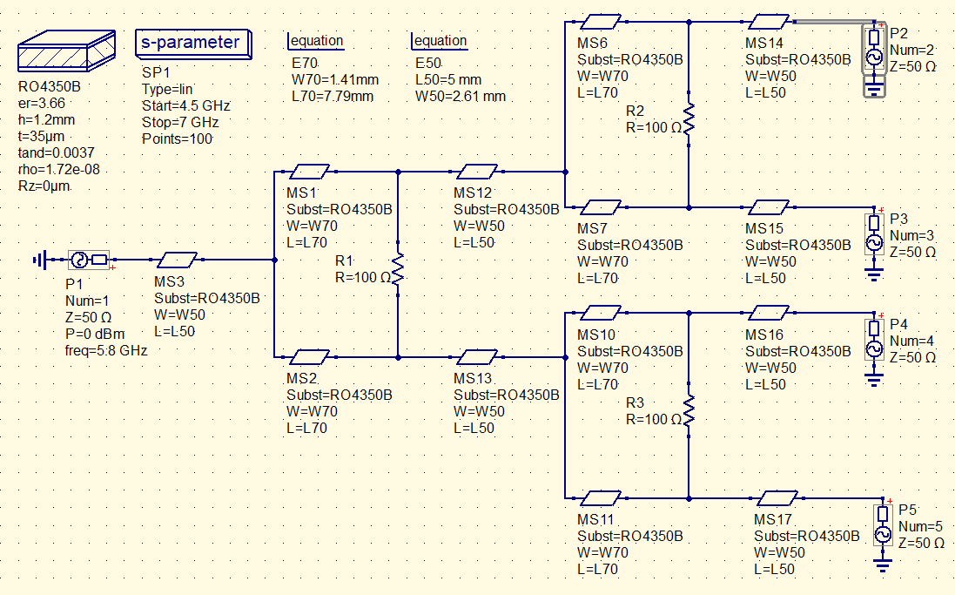
Figure 8: A 4:1 Wilkinson power divider based on cascaded 2:1 dividers was simulated to feed the antenna.
All transmission line dimensions were determined using QUCS’s built-in calculator based on the substrate. The quarter-wavelength (L70) was calculated based on the effective dielectric value:
$$ε_{eff}=\frac{ε_{r}+1}{2}+\frac{ε_{r}-1}{2}{(1+\frac{12h}{W})}^{-0.5}$$
$$=\frac{3.66+1}{2}+\frac{3.66-1}{2}{(1+\frac{12(1.2 mm)}{(1.41 mm)})}^{-0.5}≈2.725$$
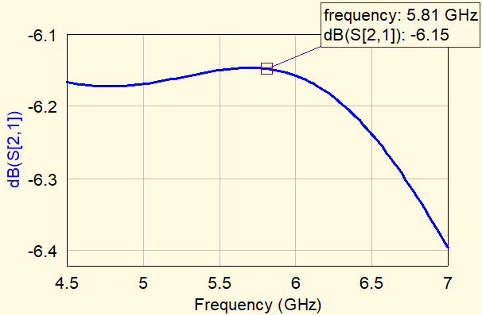
Figure 9: Plot of S21, demonstrating an insertion loss of around -6.15 dB.
The “SnP” component represents a touchstone file containing the S-parameters for each antenna array port.
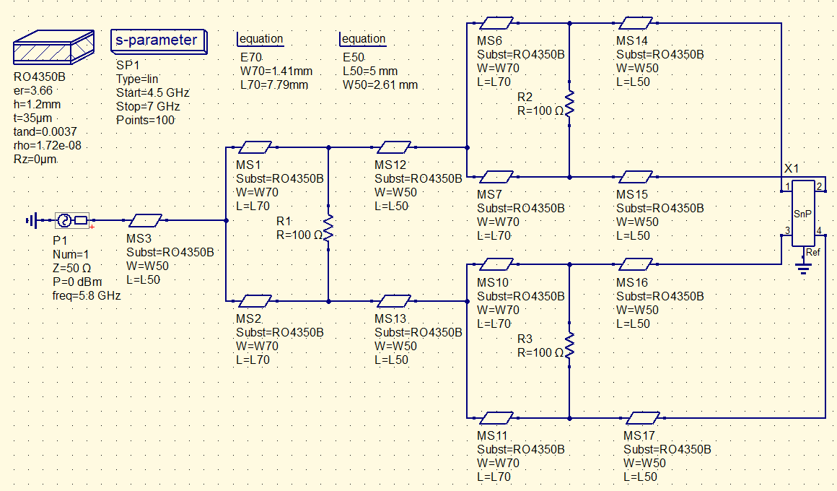
Figure 10: Power divider schematic with antenna attached.
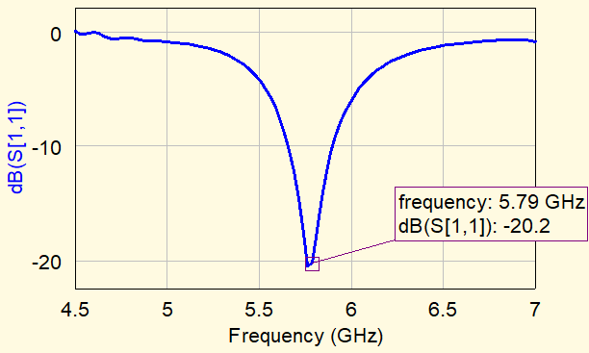
Figure 11: S11 result with antenna load, demonstrating -20 dB matching to $f_{0}$.

Conclusion and Next Steps
In conclusion, our designed antenna array meets the parameters we set out in the introduction. However, there remains several areas to improve.
The high sidelobe levels on the extreme ends of the steering range must be tapered. A potential method to explore would be to optimize the complex excitation coefficients of each array element, allowing both the amplitude and phase of the elements to be adjusted. Since the array factor is determined by the excitation coefficients of the array elements, optimizing this would provide greater control over the resulting radiation pattern.
Second, a full electromagnetic simulation of the divider and antenna array in CST would help to more fully characterize the system. Third, a physical PCB model of the system should be produced to compare to these simulated values. Lastly, to adapt this antenna for the receiving case, each antenna array should be connected to a low-noise amplifier and phase shifting electronics. This is to boost the received signal and ensure it is coherently reconstructed.

Reference List
[1] Elsevier, "Microstrip Patch Antenna Calculator," *ScienceDirect*. [Online]. Available: [https://www.sciencedirect.com/science/article/pii/S1110016821002921](https://www.sciencedirect.com/science/article/pii/S1110016821002921)
[2] M. Joler and L. Mihalić, "A Subtlety of Sizing the Inset Gap Width of a Microstrip Antenna When Built on an Ultra-Thin Substrate in the S-Band," *Sensors*, vol. 23, no. 1, p. 213, Dec. 2022. doi: 10.3390/s23010213.
[3] "Microstrip Patch Antenna Calculator," *Everything RF*. [Online]. Available: [https://www.everythingrf.com/rf-calculators/microstrip-patch-antenna-calculator](https://www.everythingrf.com/rf-calculators/microstrip-patch-antenna-calculator)

